**Auto Save Scene Tool Documentation**

This tool is designed to save the scenes you have open at an interval of your choosing. This is great for those who are deep in their work and forget to press save every now and then.

**NOTE:** This tool has to remain open for the tool work. If closes with the x on the window or tab the tool will be disabled.

**Open the window**

This tool can be opened in three ways:

1. If you are using the J-Tools window you can open and close the window from that window’s buttons.
2. You can open the window by going to the following path: ***Window -> AutoSaveScene.***
3. If you are on windows you can use the shortcut **Shift-A** to open the window.

**Summary**

Setting up the tool for use

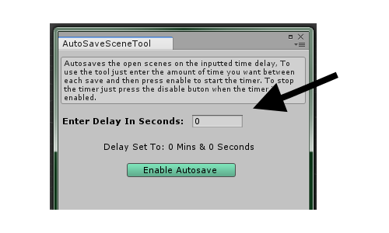This isn’t a difficult task, as there isn’t much to it. Simple enter the amount of time in seconds into the “Enter Delay In Seconds” box.

Below this box is a line of text that displays the seconds entered in minutes and seconds for your convivence. This also allow you the check you entered the right time in seconds.

Starting & Stopping the Tool

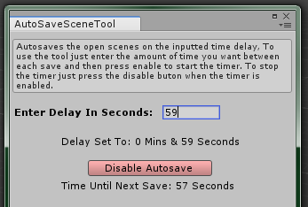To Start the tool, simply press the “Enable Autosave” button. This will change to a “Disable Autosave” button when pressed which is used to stop the tool when desired. Once you press the “Enable Autosave” button another line of text will appear showing the amount of time left until the next save will occur, it is purely there for show and just counts down in seconds.